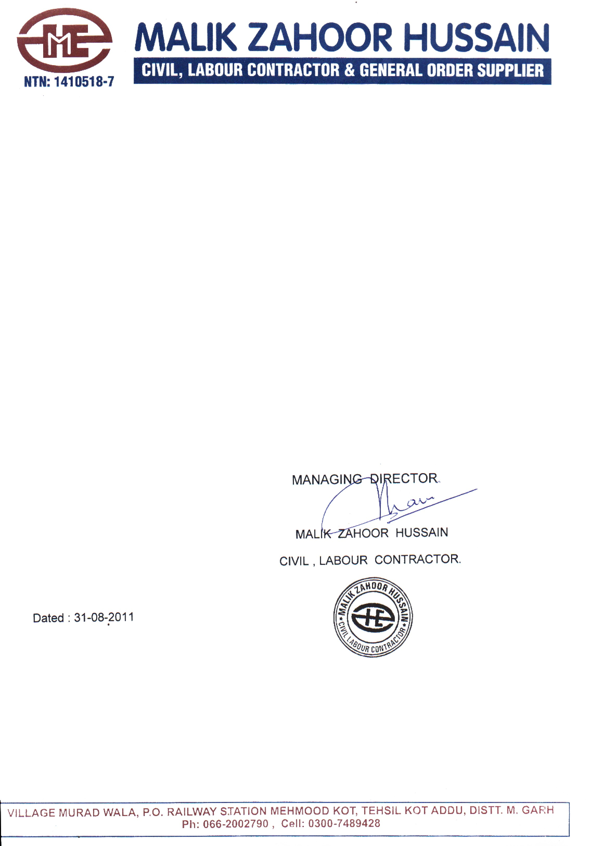

**TO WHOM IT MAY CONCERN**

This is certify that <Name> S/O <fname> has been worked as <Designation> in ZHC Company at Pak-Arab Refinery Limited (PARCO) Qasba Gujrat, District Muzaffar Garh from <From> to <To>.

He is very hard working, honest & regular in his job and always striving to achieve the very best for the Company. He is very dedicated worker and Co-operative to his follows and trustworthy.

We wish him good luck in his future.